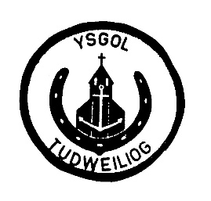 Ysgol Tudweiliog Governing Body

2019 – 2020

|  |  |  |
| --- | --- | --- |
| Name | Role | Representing |
| Seimon Glyn | Vice Chairman | LEA |
| Siwsan Griffith |  | LEA |
| Owain Griffith | Chairman | Parents |
| Elen Jones |  | Parents |
| Mitchell Rowlands |  | Parents |
| Terry Hughes |  | Co-opted |
| Janice Jones |  | Co-opted |
| Laura Hughes |  | Co-opted |
| Julie Williams |  | Teachers |
| Angharad Jones |  | Auxiliary Staff |
| Einir Davies | Headteacher |  |

|  |  |
| --- | --- |
| SEN Representative | Siwsan Griffith |
| Child Protection Representative | Seimon Glyn |
| Racial Equality Representative | Elen Jones |
| Welsh Language Charter Representative | Angharad Jones |
| Eco Schools Representative | Elen Jones |
| Attendance Representative | Seimon Glyn |
| Health and Safety and Buildings Representative | Owain Griffith |

Clerc y Corff Llywodraethol : Eirian Williams